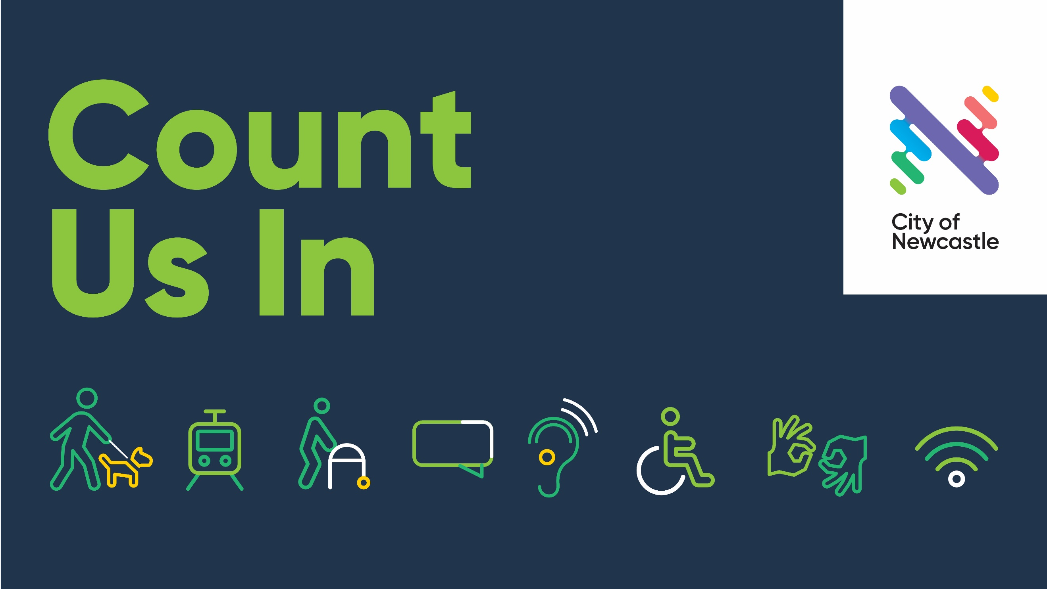
Program Guide
13-28 May 2022

newcastle.nsw.gov.au/countusin2022

Count Us In was initiated by the City of Newcastle in consultation with our Access Inclusion Advisory Committee and the 2022 program has been shaped and co-designed by Community Disability Alliance Hunter (CDAH)

The program aims to increase disability inclusion across our community, demonstrate diversity of disabilities and highlight contributions made by people with disabilities.

This Program Guide includes a description of the wide range of events and activities within the program and the relevant booking information. Enjoy!
2022 Count Us In Festival

Event Calendar 13–28 May, 2022

Friday 13 May

Event Hunter Disability Expo
Description Visit City of Newcastle Stall along with Community Disability Alliance Hunter (CDAH) at the Expo and find out about local activities and events, along with suppliers and services. Free to attend, but you need to register.
Time 9am – 3pm
Location Newcastle Entertainment Centre
Bookings/Enquiries Register to attend or visit https://www.hunterdisabilityexpo.com.au/

Event Tourette's Superpower
Description This event hosted by the University of Newcastle will provide knowledge, insight, celebration and connection for neurodivergent people in our community. Learn more about Tourette's and how to reduce stigma and help create a more inclusive community.
Time 10:30am – 12:30pm
Location University of Newcastle
Bookings https://www.trybooking.com/BZGAJ
Enquiries Email: Jess.McGowan@newcastle.edu.au

Event Library After Dark-The Dark Spoken Word Drag Bar
Description A night out at the library with a DJ and Drag performers as your host. Catastrophe, superstitions & dark gloomy glorious drag, it's Friday 13th and these performers will tantalize your spidery senses as they dance their way through the spoken word. This is an 18+ event. A part of the Autumn Alive Festival.
Time 5pm – 9pm
Location Newcastle Library
Bookings/Enquiries https://whatson.newcastle.nsw.gov.au/event/library-after-dark-the-dark-spoken-word-drag-bar-n

Event Movies in Museum Park -Beauty and the Beast (1991)
Description Bring a picnic rug or chairs and enjoy an outdoor movie in Museum Park which will include closed captions. This event is part of the Autumn Alive festival and best of all, it is free. Food and drinks available on site.
Time 6pm – 9pm (Movie starts around 6:30pm, 84 mins running time)
Location Museum Park Lawn.
Bookings/Enquiries More information visit https://newcastlemuseum.com.au/what-s-on/current-events/movies-in-museum-park

Saturday 14 May

Event Hunter Disability Expo
Description Visit City of Newcastle Stall along with Community Disability Alliance Hunter (CDAH) at the Expo, find out about local activities, events, suppliers and services, and there is entertainment! Free to attend but you must book.
Time 9am – 3pm
Location Newcastle Entertainment Centre
Bookings/Enquiries Register to attend or visit https://www.hunterdisabilityexpo.com.au/

Monday 16 May

Event Accessible Fishing at the Wetlands
Description Learn and enjoy fishing on the accessible platform at the Wetlands, experience the relaxation of the natural environment, view the reptiles and other displays.
Time 10am-12noon
Location Hunter Wetlands Centre, 1 Wetlands Place, Shortland
Bookings/Enquiries Bookings essential. Contact Bruce via email marketing@wetlands.org.au

Event Earthen Rhythms Drum Workshop
Description Join in the fun and experience this drum workshop/circle. Earthen Rhythms has provided thousands of drum workshops and these are delivered in an inclusive way so everyone can benefit from the joy of music and team work.
Time 10:30am-11:30am
Location Hamilton
Bookings/Enquiries Contact Benjie on 0407 177 564

Wednesday 18 May

Event City of Newcastle Business Breakfast
Description Inclusion is everyone's business, and this event will focus on workplace inclusion. To be an inclusive community people with disabilities need access to meaningful employment and also know that in the workplace they will experience positive attitudes and behaviours. Your MC is Natasha Beyersdorf. Speakers include Paralympian and Broadcaster, Christy Dawes, Hunter Diversity and Inclusion Collective Chairperson/Co-founder, Bill Armstrong and CDAH representative Dave Belcher.
Time 7am-8:45am
Location City Hall, Newcastle
Bookings https://www.trybooking.com/BZHFP
Enquiries sally@canvaseventsco.com.au

Event Newskillz-Lifeskills
Description Enjoy this fun and engaging activity focused on nutrition, exercise and wellbeing delivered in an inclusive and supportive environment by Aruba Health Professionals. This workshop promotes learning life skills so people with disabilities can live a more healthy and independent life.
Time 10am-1pm
Location 14 Alma Road, New Lambton NSW 2305
Bookings/Enquiries Book now https://www.trybooking.com/events/landing?eid=904306&
More info contact 4081 1828

Thursday 19 May

Event Accessible Fishing at the Wetlands
Description Learn and enjoy fishing on the accessible platform at the Wetlands, experience the relaxation of the natural environment, view the reptiles and other displays.
Time 10am-12noon
Location Hunter Wetlands Centre, 1 Wetlands Place, Shortland
Bookings/Enquiries Bookings essential. Contact Bruce via email marketing@wetlands.org.au

Event Library After Dark: Bad Art Party with local artists Jen Denzin and Joanne Back
Description No art skills? No problem! Bard Art Party is a social art event filled with kitschy craft making and is all about fun. Food, drinks, music, what more could you want. This is an 18+ event. Part of the Autumn Alive Festival.
Time 5pm-9pm
Location Newcastle Library
Bookings/Enquiries https://whatson.newcastle.nsw.gov.au/event/library-after-dark-bad-art-party-with-local-artist

Event Newcastle Transport Travel Experience Day
Description This day will assist customers become more familiar with public transport. Practice boarding a tram, bus or ferry in a static situation. Build travel confidence and chat to staff to find out more about how we can assist.
Time 10am-12noon
Location Newcastle Interchange, Stewart Avenue, Newcastle West.
Bookings/Enquiries Book now or complete the registration form via this link https://form.jotform.com/221150784126046

Event Advisory Committee Coffee and Chat
Description Meet the City of Newcastle's Access Inclusion Advisory Committee (AIAC) Join us for a social chat about all things inclusion, find out about the role of the AIAC as it begins its' new term. The AIAC members are 3 Councillors, 3 organizational representatives and 4 community representatives. AIAC provides advice to Council on matters related to disability inclusion. Join us for our meeting and morning tea.
Time 10am-12noon
Location Newcastle Room, City Hall. Accessible entry from western door on ground floor.
Bookings/Enquiries Call Steve on 0419 616 818 or email swarham@ncc.nsw.gov.au

Friday 20 May

Event Movies in Museum Park -The Jungle Book (1967)
Description Bring a picnic rug or chairs and enjoy an outdoor movie in Museum Park which will include closed captions. This event is part of the Autumn Alive festival and best of all it is free. Food and drinks available on site.
Time 6pm – 9pm (Movie starts around 6:30pm, 78 mins running time)
Location Museum Park Lawn.
Bookings/Enquiries More information visit https://newcastlemuseum.com.au/what-s-on/current-events/movies-in-museum-park

Event Speak Up Hunter Social Event
Description Join Sarah and Aaron for your opportunity to socialize with peers at Wickham Park Hotel. Speak Up Hunter helps people with disabilities to share in social events, make new friendships and at the same time be seen in the community, out and enjoying themselves just like anyone else!
Time 5pm onwards
Location Wickham Park Hotel
Bookings/Enquiries No Booking Required. More information contact CDAH on Ph 0490 053 454 or email info@cdah.org.au

Event Library After Dark: Club Kid Rave and Bar
Description Join drag performers Timberline and Molly Poppinz for a night of electronic, RnB/Hip hop mixed music and dance. This is an 18+ event. Part of the Autumn Alive festival.
Time 5pm-10pm
Location Newcastle Library
Bookings/Enquiries https://whatson.newcastle.nsw.gov.au/event/library-after-dark-club-kid-rave-and-bar-newcastle

Saturday 21 May

Event Family Fun Day-Joblink Plus
Description Enjoy a family fun day at Blackbutt Reserve including visiting the animal enclosures. A great opportunity for people with disabilities, carers and family members to enjoy a day out. Talk to Joblink Plus in a casual environment about services they provide to assist people get job ready and also get into the workforce.
Time 11 am - 2 pm
Location Blackbutt Reserve, Carnley Avenue, Kotara
Bookings/Enquiries For more information contact veronica.matheson@joblinkplus.com.au

Event CDAH Queer Peers Social
Description Meet and greet people with lived experience of disabilities who also identify as LGBTQIA. Just a social get together to offer friendship and support. Your hosts are Shaylie and Owen.
Time 3pm – 5pm
Location The Station, Corner of Watt and Scott Streets, Newcastle.
Bookings/Enquiries No booking required. More information contact CDAH on
Ph 0490 053 454 or email info@cdah.org.au

Sunday 22 May

Event Inclusive Arts at Playstate Gallery
Description Arts experience including for the Deaf and Hard of Hearing communities
Time 3pm – 5pm
Location Playstate Gallery – Cooks Hill.
Bookings/Enquiries Bookings Essential. Phone Sophie 0481 183 310 or
email sophie@playstate.com.au

Monday 23 May

Event CDAH Sports and Zumba Session
Description Fun, recreation and exercise with your hosts Sarah and Aaron. Come on down and get down to inclusive Zumba and adapted sports.
Time 10am-1pm
Location Newcastle Foreshore, Old Train Sheds
Bookings/Enquiries More information contact CDAH on Ph 0490 053 454 or email info@cdah.org.au

Event The Art of Digital Story Telling, 3D Animation, Design and Gaming
Description F This course commences on 23 May and runs through to 10 June, 3 days a week from 10am-3pm each day. Providing people on the NDIS the opportunity to learn valuable skills for employment and fun who are interested in the digital world and animation and other creative formats.
Time 10am-3pm
Location Newcastle Digital Library, 12 Stewart Avenue, Newcastle West.
Bookings/Enquiries More information contact visit https://growthcommunity.com.au/the-art-of-digital-storytelling/

Tuesday 24 May

Event Employment Forum
Description This forum on disability employment will listen to voices and experience of people with disabilities, disability employment agencies and the business community to inform how we can create better outcomes and increase pathways to employment for people with disabilities.
Time 10:30am-1:30pm
Location Wallsend Diggers Club, Wallsend.
Bookings https://www.trybooking.com/events/landing?eid=902609&
Enquiries Contact Richelle Hedstrom rhedstrom@ncc.nsw.gov.au

Event Earthen Rhythms Drum Workshop
Description Join in the fun and experience this drum workshop/circle. Earthen Rhythms has provided thousands of drum workshops and these are delivered in an inclusive way so everyone can benefit from the joy of music and team work.
Time 2:30pm-3:30pm
Location Waratah
Bookings/Enquiries Contact Benjie on 0407 177 564

Wednesday 25 May

Event Newskillz-Lifeskills
Description Enjoy this fun and engaging activity focused on nutrition, exercise and wellbeing delivered in an inclusive and supportive environment by Aruba Health Professionals. This workshop promotes learning life skills so people with disabilities can live a more healthy and independent life.
Time 10am-1pm
Location 14 Alma Road, New Lambton NSW 2305.
Bookings/Enquiries Book now! https://www.trybooking.com/events/landing?eid=904306&
More info, contact 4081 1828

Event Positive Partnerships Autism Workshop for Parents and Carers
Description A one day workshop supporting parents and carers, working together to support school aged children on the autism spectrum. Join other local families to discuss how to strengthen the home-school partnership.
Time 9:15am-3pm
Location Noah's On the Beach, Newcastle.
Bookings/Enquiries Bookings essential, morning tea, light lunch and interpreters available. Visit https://www.positivepartnerships.com.au/

Event Resume Building
Description In-person and online via zoom, this workshop will cover how to prepare
and highlight your strengths via a good resume, as well as practical tips for creating cover letters and selection criteria. Joseph Popov will present this workshop and provide assistance on drafting your resume alongside CDAH peers.
Time 10:30am-12:30pm
Location CDAH Office 406/408 King Street, Newcastle and on zoom.
Bookings/Enquiries Contact 0490 053 454 or email info@cdah.org.au

Event Green Earth Peers facilitated by Leigh Creighton
Description This event will be for peers and allies to connect with each other and the natural environment to network and garner support for the Peer Group. A guided walk in Blackbutt Reserve and lunch to follow.
Time 10:00am-1pm
Location Blackbutt Reserve, New Lambton.
Bookings/Enquiries Contact 0490 053 454 or email info@cdah.org.au

Event Accessible Fishing at the Wetlands
Description Learn and enjoy fishing on the accessible platform at the Wetlands, experience the relaxation of the natural environment, view the reptiles and other displays.
Time 10am-12noon
Location Hunter Wetlands Centre, 1 Wetlands Place, Shortland
Bookings/Enquiries Bookings essential. Contact Bruce via email marketing@wetlands.org.au

Thursday 26 May

Event Earthen Rhythms Drum Workshop
Description Join in the fun and experience this drum workshop/circle. Earthen Rhythms has provided thousands of drum workshops and these are delivered in an inclusive way so everyone can benefit from the joy of music and team work.
Time Thursday 2:30pm-3:30pm
Location Civic Bar, Newcastle (Civic Theatre Building)
Bookings/Enquiries Contact Benjie on 0407 177 564

Event Accessible Science Table at the Museum
Description Join in the fun and get into science. Come and chat with Catherine our Scientist and try some hands-on activities. It's free and fun!
Time 10am-12noon
Location Newcastle Museum, 6 Workshop Way, Newcastle.
Bookings/Enquiries No bookings required, enquiries contact 4974 1400

Event Karaoke Social Night
Description Come along and share some fun times and if you are brave enough have a go at singing a tune or two in a safe supportive environment. We will be sharing some food and a few drinks whilst singing the night away.
Time 5pm-8pm
Location Civic Bar, Hunter Street Newcastle (Part of the Civic Theatre building)
Bookings/Enquiries Bookings https://www.trybooking.com/BZNGG
More info, contact sally@canvaseventsco.com.au

Friday 27 May

Event Speak Up Hunter Social Event
Description Join Sarah and Aaron for your opportunity to socialize with peers at Star Hotel. Speak Up Hunter helps people with disabilities to share in social events, make new friendships and at the same time be seen in the community, out and enjoying themselves just like anyone else!
Time 5pm onwards
Location Star Hotel, Newcastle
Bookings/Enquiries No Booking Required. More information contact CDAH on
Ph 0490 053 454 or email info@cdah.org.au

Saturday 28 May

Event Accessible Science Table at the Museum
Description Join in the fun and get into science. Come and chat with Catherine our Scientist and try some hands-on activities. It's free and fun!
Time 10am-12noon
Location Newcastle Museum, 6 Workshop Way, Newcastle.
Bookings/Enquiries No bookings required, enquiries contact 4974 1400

Event Alice's Wonderland Low Sensory Exhibition Experience at the Museum
Description Come and experience the new exhibition of Alice's Wonderland (aimed at primary school children) as a special session before our Museum officially opens. There will be no crowds and no special effects lighting or sounds. This is a paid for entry exhibition.
Time 9am-10am
Location Newcastle Museum, 6 workshop Way, Newcastle
Bookings/Enquiries Click here or visit https://www.newcastlemuseum.com.au/exhibitions/special-exhibitions/alice-s-wonderland

Event Families Supporting Families Inclusive Disco
Description Families Supporting Families along with Chance2Dance are hosting a fun afternoon of dance and disco. The event will include some performance pieces and also lots of opportunity to move and enjoy the music. A social event for people with disabilities, families and significant others.
Time 3pm-5pm
Location Nobbys Beach Surf Life Saving Club House
Bookings/Enquiries Contact Eilis Corrigan on Ph 0437 310 288 or email info@familiessupportingfamilies.com

Want More?
Interested in Disability Awareness Training?

City of Newcastle is offering free disability awareness training as a follow on from Count Us In 2022.

Course 1 Details

When Monday 30 May
Event Let's Talk Disability Online Disability Awareness Training
Description Undertake this 90 minute online learning experience to hear from people with lived experience of disabilities about how to build a more inclusive workplace and community. Explore disability myths and enjoy this engaging learning experience from a team of presenters.
Time 10am-11:30am
Location Online via Zoom
Bookings/Enquiries Booking essential. Contact swarham@ncc.nsw.gov.au or call Steve on 49742863

Course 2-To be confirmed subject to demand.

Event

