Gregson Park Masterplan Survey
Gregson Park Masterplan
Phase One: Engagement Survey Questions
- Tell us how you use Gregson Park and what you’d like to see there in the future.

- Your ideas will help inform the Gregson Park Masterplan, which will guide the future of the park.

- This survey will take about 5 minutes to complete.

- Have your say until 5pm Wednesday 30 September.

Privacy
We will not record any personal information from the survey. All your feedback is anonymous.

Need help?
If you have any questions or require alternative supports to inform us or take the survey, please phone 4974 2000 during business hours or email engage@ncc.nsw.gov.au

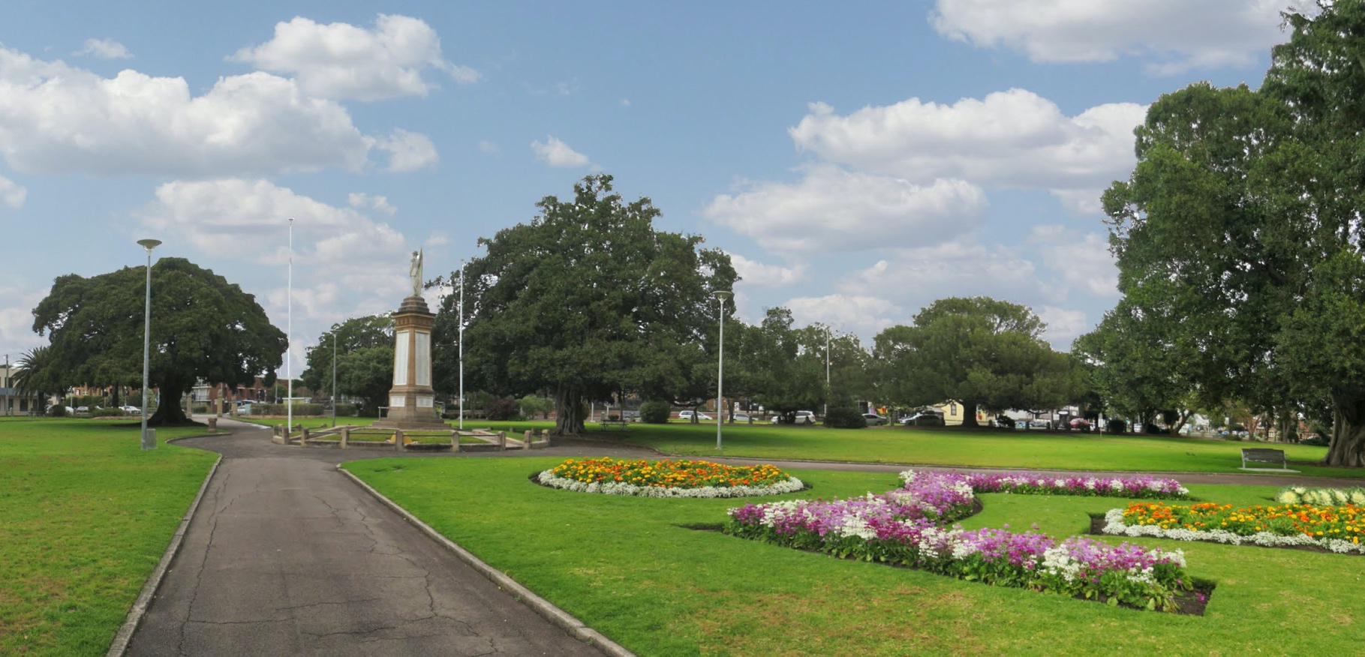
Phase One: Engagement Survey Questions

On average, how often do you visit Gregson Park, Hamilton?
(Single response only)
Daily Weekly
Every few weeks Monthly
Every few months Every 6 months Every 12 months +

- What type of transport do you use to get to or from Gregson Park? (Select all that apply)

Car Bus
Walk /run Cycle
Motorcycle / motorised scooter Skateboard / push scooter
Other: Please comment

- Do you use any of the following facilities at Gregson Park? (Select all that apply)

Playspace
Shelter outside the toilet block Path networks in the park Toilets
Tennis courts
Uncovered seating areas
Uncovered picnic tables
Picnic tables in the sheltered BBQ area BBQ
Water fountain
I don’t use any of these

Do you do any of the following recreational activities in Gregson Park?
(Select all that apply)

Walk, run or cycle on the path network in the park Group exercise
Walk the dog Picnic or barbecue
Active use in the open space (E.g ball games, frisbee etc)
Passive use
(E.g sit and read / enjoy the scenery) Pass through to get to another location Attend community events
Attend local gatherings / meet up groups
Other: Please comment

Which of the following elements do you love most about Gregson Park?
(Select all that apply)

Grassy areas / green space Trees
Flowers and gardens Quiet outdoor space
Memorials and heritage elements
Spaces for play
BBQs and picnic shelter Tennis Courts and Club House
The community ‘feel’ of the park

In the future, which of the following would you like to see more of at Gregson Park?
(Select all that apply):

Natural Elements and Heritage:
Trees
Formal gardens Bush Tucker gardens
Heritage interpretation Indigenous elements Memorials

Recreation:
Pop-up activities (E.g food trucks, night-time cinema, etc) Interactive artworks and sculpture Youth-oriented activity
Exercise equipment Sports courts Markets

Amenities:
Water fountain Seating Accessible toilets BBQs
Tables and benches Shade structures Inclusive playspace Picnic areas
Event space Café

Connectivity:
Signage to help me find my way around Bike parking
Improved bicycle paths Improved walking paths
Improved connectivity to surrounding areas for pedestrians (E.g crossings)

Do you have any other comments about what you would like to see more of at Gregson Park?

Playspace intro
The new playspace at Gregson Park will be a space for families and friends of all ages to gather, spend time and play.

- What kind of spaces would you like to have in the playspace? (Select all that apply)

Climbing agility Reading area Quiet space Sensory spaces
Enclosed areas (E.g caves/tunnels) Water play
Zones for age groups Don’t know/NA
Other: Please comment

- What do you (or your children) like to do in a playspace? (Select all that apply)

Play games with others Meet new friends Gather for celebrations Relax
Spend time engaging with nature Physical play
Don’t know/NA
Other: Please comment

- We want Gregson Park to be a place we can all enjoy. Is there anything that currently takes away from your enjoyment of the park? (E.g lack of facilities, cleanliness, safety etc) Please comment (optional)

Demographics

What is your age?
Under 12 years old 12 – 17 years
18 – 24 years
25 – 34 years
35 – 44 years

45 – 54 years
55 – 65 years
65 – 74 years
75+
Prefer not to answer

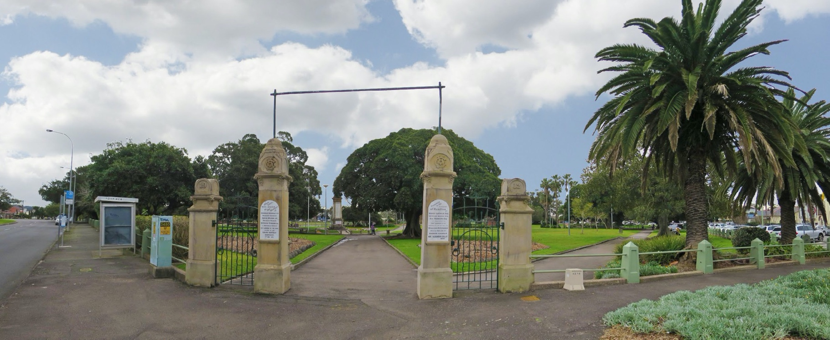
Phase One: Engagement Survey Questions

What is your gender?
Male Female
Transgender/Intersex/Other Prefer not to say

- Do you identify as a person with a disability? (Select one response only)
Yes No

What is your suburb?

